Hoa Sen (Bông Sen)
Translated by Katherine Thuy Miller, June 20, 2011
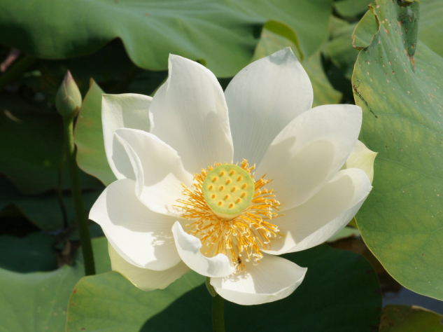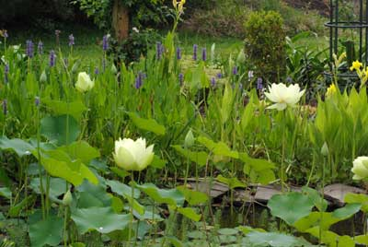

Hoa Sen
Trong đầm gì đẹp bằng Sen?
Lá xanh bông trắng lại chen nhụy vàng,
Nhụy vàng, bông trắng lá xanh,
Gần bùn mà chẳng hôi tanh mùi bùn!

The Lotus
What is prettier than The Lotus in the pond?
Green leaves, white petals, inserted by yellow pistil;
Yellow pistil, white petals, green leaves;
Though living in the mud, The Lotus never stinks!

